Worship
05PT526
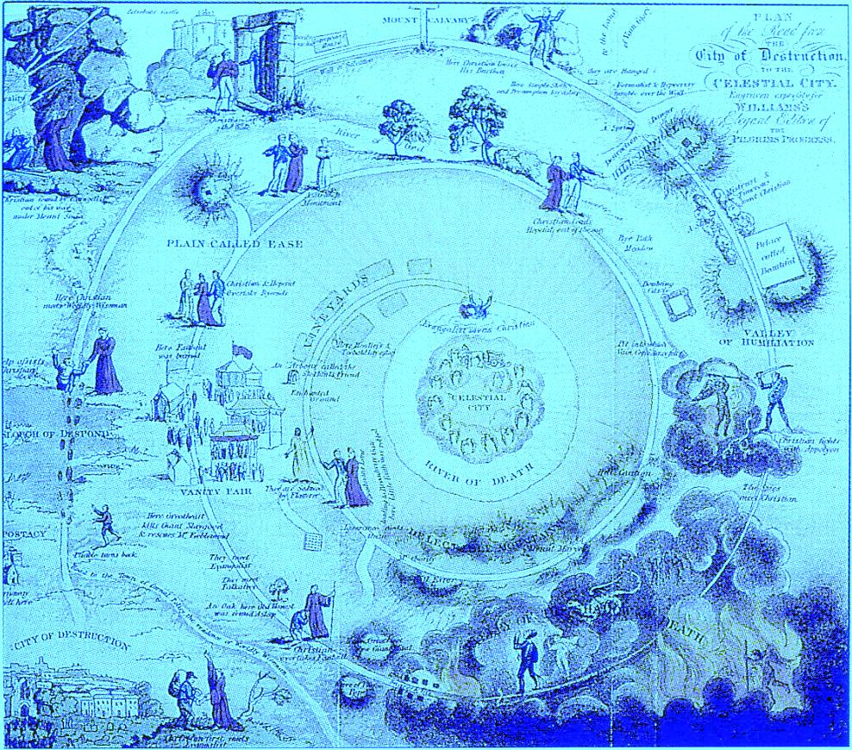

“…you have come to Mount Zion and to the city of the living God, the heavenly Jerusalem, to innumerable angels in festal gathering and to the church of the firstborn who are enrolled in heaven and to God.” (Hebrews 12:22-23)
Reformed Theological Seminary-Houston
Fall 2015

Worship - 05PT526
Course Syllabus – Fall 2015
Instructor: | Associate Professor Michael Glodo
Contact information: | Professor Glodo: mglodo@rts.edu, 407.278.4476  Administrative Assistant Joyce Sisler :jsisler@rts.edu), 407.278.4552  Teaching assistant: Tim Inman (tinman@rts.edu)
Communication: | I prefer communicating in person, but email is fine, too. If we are Facebook “friends,” please don’t use the messaging function in place of email. Please make certain that my email address is on your “safe senders list” so that no course communications get routed to your junk mail folder.
Class meeting: | 6:30-9:30 p.m. Fridays and 8:00 a.m. - 3:00 p.m. Saturdays on the weekends of September 25-26, October 30-31 and November 20-21.
Course web page: | Register as a user at https://rts.instructure.com/login. Near the start of the semester you will receive an email invitation to join the course. Please be sure to keep your email address up to date.

Course description.
The biblical foundations of worship, including music, worship strategies, creative styles, and worship for special occasions are considered in this course. The goal is to prepare students to be worshippers and effective leaders in worship. 2 credits.

Course objectives.

Knowing:
- Develop a biblical theology of worship.
- Understand the history of worship, particularly within the Reformed tradition.
- Discernment of various worship practices.
- Knowledge of a greater range of resources for planning and implementing worship.

Being:
- Experience greater intimacy with God through class exercises and participation in worship in the local church.
- Desire to be more Christlike through the ordinary and outward means God has given which are especially provided through worship.
- Develop clearer and deeper convictions about how worship may best glorify God and enable God’s people to enjoy Him.

Doing:
- Ability to plan worship.
- Ability to lead others in worship.

Course requirements.
Assignment |  | Due
Public Prayer Project (7) | 15 | Weekly at 8:00 p.m. starting Oct. 3
Exams (3) | 30 | By 8:00 p.m. on Saturday one week after each class meeting
Reading report | 10 | Oct 30 @ start of class
Orders of worship (2) | 15 | Dec 5 by 8:00 p.m.
Philosophy of worship paper | 20 | Dec. 12 by 8:00 p.m.
Total | 100

Course materials.
Course materials will be available on the course web page on Canvas. If you have not previously signed up for Canvas, please do so.
Lecture handouts may include Hebrew and Greek using the SBL Hebrew and SBL Greek fonts. These are free downloadable fonts at http://www.sbl-site.org/educational/BiblicalFonts_SBLHebrew.aspx and http://www.sbl-site.org/educational/BiblicalFonts_SBLGreek.aspx, respectively. These fonts will be used frequently in other courses throughout your program of study.

Required reading.
The following is to be read to go along with the lectures and to be incorporated in the assignments.
Old, Hughes Oliphant. Worship Reformed according to Scripture. Rev. Ed. Rev Exp. Louisville, KY: Westminster John Knox Press, 2002. Isbn 978-0664225797. 208pp.
Ryken, Philip G., J. Ligon Duncan, and Derek Thomas, eds. Give Praise to God. Phillipsburg, N.J.: P & R Publishing, 2011. Isbn 978-1596383920. 536 pp.
Quill, Timothy, Ligon Duncan, Dan Wilt, Michael Lawrence, Mark Dever, and Dan Kimball. Perspectives on Christian Worship: Five Views. Edited by J. Matthew Pinson. Nashville, TN: B&H Academic, 2009. Isbn 978-0805440997. 368pp.

Book report reading.
You are to select from the following reading according to the “Reading report” assignment described below.
Chapell, Bryan. Christ-Centered Worship: Letting the Gospel Shape Our Practice. Grand Rapids, MI: Baker Academic, 2009.
Dawn, Marva J. A Royal Waste of Time: The Splendor of Worshiping God and Being Church for the World. Grand Rapids, MI: William B. Eerdmans Publishing Company, 1999.
Hart, D. G., and John R. Muether. With Reverence and Awe: Returning to the Basics of Reformed Worship. Phillipsburg, NJ: P & R Publishing, 2002.
Hughes, R. Kent, Timothy J. Keller, and Mark Ashton. Worship by the Book. Edited by D.A. Carson. Grand Rapids, MI: Zondervan, 2002.
Neste, Ray Van, and C. Richard Wells, eds. Forgotten Songs: Reclaiming the Psalms for Christian Worship. Nashville, TN: B&H Academic, 2012.
Smith, James K. A. Imagining the Kingdom: How Worship Works. Grand Rapids, MI: Baker Academic, 2013.
Thompson, Bard. Liturgies of the Western Church. Philadelphia: Fortress Press, 1980.
Webber, Robert E., and John Witvliet. Ancient-Future Worship: Proclaiming and Enacting God’s Narrative. Grand Rapids, MI: Baker Books, 2008.

Exams
There will be a modest open notes exam consisting of 4-6 essay questions for each of the three weekend class meetings. The exams will be taken on Canvas and will be due by 8:00 p.m. on the Saturday evening a week after each class meeting weekend.

Public Prayer Project
Based on your reading of Hughes Old’s Leading in Prayer, you will complete the seven public prayer assignments contained below in this syllabus. These are due weekly after the start of the class and to be submitted by copying and pasting your completed work into the appropriate assignment on Canvas.

Orders of Worship
Each student will prepare two full orders of worship which will be due on the date indicated above. These are to be submitted as Microsoft Word or Rich Text Format documents using Canvas.
Reading Report
Each student will select one of the works listed above to read and write a 3-5 page (single-spaced) summary and critical assessment which will be shared with the rest of the class. Since the length of the book choices varies, you are only required to read 175 pages of the work you select. You must inform me of your choice so that we have maximum coverage of different books. If there is a book not on the list which you would like to propose, you may ask me about choosing it. Papers should be submitted in Microsoft Word or Rich Text Format using Canvas.
Philosophy of Worship Paper
Each student will write a 7-10 page (single-spaced) paper articulating his philosophy of worship, integrating reading and lecture materials. Class meetings will develop the questions and issues to be addressed in this paper. Papers should be submitted in Microsoft Word or Rich Text Format using Canvas.

Prayer Project
Following are the specific assignments for the prayer project described in your syllabus. These assignments are to be submitted in text form (not document upload) on Canvas. This document is provided as a template for those assignments and for a place to store your cumulative work. It is recommended that you complete your work in this document, save the document and copy and paste each specific assignment to the appropriate place on Canvas.

Prayer Project Assignment 1: Invocations Due 10/2/2015
Reading: Old, pp. 11-23
What are the six biblical elements of an invocation?

Describe the three parts of an invocation.

Choose a scripture sentence appropriate to introduce an invocation and then write a prayer of invocation incorporating the above six elements in the three parts.

Prayer Project Assignment 2: Psalms as Prayer Due 10/9/2015
Reading: Old, pp. 55-75
- What is a metrical psalm?

- Why should a call to worship not replace the reading of a psalm?

- What are the considerations for choosing particular psalms for a worship service?

- What are the three ways one may work metrical psalmody into a worship service?

- Choose a psalm to read responsively with your family, small group, Sunday school class or worship service. After doing so, describe the experience.

Prayer Project Assignment 3: Prayers of Confession & Supplication Due 10/16/2015
Reading: Old 77-90
- According to Matthew Henry and Isaac Watts, what should be included in a prayer of confession?

- What is a prayer of supplication?

- What are the benefits and limitations of using standard congregational prayers of confession and supplication?

- Choosing a scripture passage(s) on which to base it, write a prayer of confession and supplication along with a scriptural assurance of pardon (in the actual words you would use in a worship service).

Prayer Project Assignment 4: Prayer for Illumination Due 10/23/2015
Reading: Old pp. 139-52
- Why should we pray prayers of illumination?

- What should we pray for in a prayer of illumination?

- Compose a prayer for illumination using scriptural expressions.

Prayer Project Assignment 5: Prayers of Intercession Due 10/30/2015
Reading: Old 175-95
- What are the theological foundations for intercessory prayer in public worship?

- What are the five areas of intercession delineated in Olds’ sample prayers?

- Compose a prayer of intercession using scriptural phrases.

Prayer Project Assignment 6: Prayers of Thanksgiving Due 11/9/2015
Reading: Old 291-306
- What three components of a thanksgiving prayer does Isaac Watts recommend?

- Choose a psalm of thanksgiving and compose a prayer of thanksgiving following the contours of that psalm.

Prayer Project Assignment 7: The Ordering of Public Prayer Due 11/13/2015
Reading: Old 361-70
Reflect by responding to the following questions:
- Has this prayer project (readings, lectures and assignments) changed your outlook on prayer in worship? If so, how?

- In what way do you think your church could grow most in public prayer together?

- What personal challenges has this prayer project presented to you?

Course Objectives Related to MDiv* Student Learning Outcomes
Course: 2PT528 (Theology of Ministry I)
Professor: Michael J. Glodo
Campus: Orlando
Date: Fall 2012
MDiv* Student Learning Outcomes  In order to measure the success of the MDiv curriculum, RTS has defined the following as the intended outcomes of the student learning process. Each course contributes to these overall outcomes. This rubric shows the contribution of this course to the MDiv outcomes.  *As the MDiv is the core degree at RTS, the MDiv rubric will be used in this syllabus. |  | Rubric  - Strong  - Moderate  - Minimal  - None | Mini-Justification
Articulation  (oral & written) | Broadly understands and articulates knowledge, both oral and written, of essential biblical, theological, historical, and cultural/global information, including details, concepts, and frameworks. | Strong | Students, using a variety of written assignments, are required to articulate a philosophy of ministry based on biblical and theological standards which have relevance in the contemporary context
Scripture | Significant knowledge of the original meaning of Scripture. Also, the concepts for and skill to research further into the original meaning of Scripture and to apply Scripture to a variety of modern circumstances. (Includes appropriate use of original languages and hermeneutics; and integrates theological, historical, and cultural/global perspectives.) | Moderate | Lectures draw significantly from Scripture. Students must articulate a philosophy of ministry which is justified by biblical standards.
Reformed Theology | Significant knowledge of Reformed theology and practice, with emphasis on the Westminster Standards. | Strong | Distinctives of a Reformed view of ministry of Word and sacrament provide the foundations for this course. Students much articulate and understanding of this approach and interact with it.
Sanctification | Demonstrates a love for the Triune God that aids the student’s sanctification. | Strong | A significant proportion of time is spent on the subject and processes of self-knowledge as they relate to ministry. Students must write paper reflecting successes and failures in real-world situations in relation to their own character. In this process students must articulate the biblical norms for ministers and reflect upon their own readiness in relation to them.
Desire for Worldview | Burning desire to conform all of life to the Word of God. | Moderate | Students’ theology of ministry must be articulated in terms of the church’s and the ministry’s larger role in society.
Winsomely Reformed | Embraces a winsomely Reformed ethos. (Includes an appropriate ecumenical spirit with other Christians, especially Evangelicals; a concern to present the Gospel in a God-honoring manner to non-Christians; and a truth-in-love attitude in disagreements.) | Strong | Alternative viewpoints within Reformed parameters as well as those selectively outside of it are acknowledge and explained charitably.
Preach | Ability to preach and teach the meaning of Scripture to both heart and mind with clarity and enthusiasm. | Minimal | Students will challenged to consider how preaching fits within the larger framework of a philosophy of ministry.
Worship | Knowledgeable of historic and modern Christian-worship forms; and ability to construct and skill to lead a worship service. | Moderate | Worship as a responsibility area of the minister will be presented and reflected upon in assignments
Shepherd | Ability to shepherd the local congregation: aiding in spiritual maturity; promoting use of gifts and callings; and encouraging a concern for non-Christians, both in America and worldwide. | Strong | The role of minister as shepherd predominates class presentations and must be reflected upon in all written assignments.
Church/World | Ability to interact within a denominational context, within the broader worldwide church, and with significant public issues. | Strong | Students must relate their philosophy of ministry to their specific ministry contexts and are challenged to consider how they will actively relate to various broadening circles of ministry relationship.

