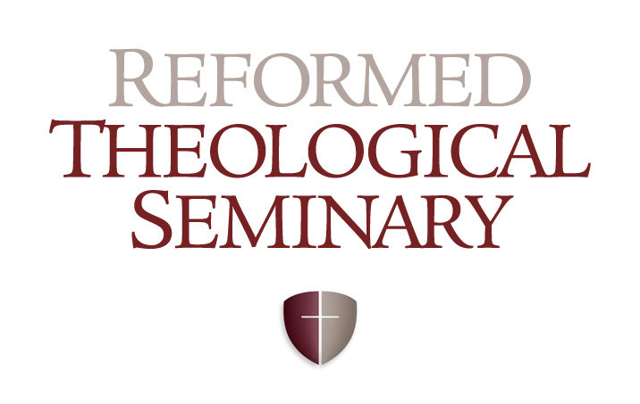
Houston

Greek Exegesis (11NT506/01)
Summer 2019 Intensive

June 11-14 (Tuesday-Friday)
Tuesday: 1:00pm-6:00pm
Wednesday: 8:30am-5:00pm
Thursday: 8:30am-5:00pm
Friday: 8:30am-3:30pm

Dr. Ben C. Dunson

PROFESSOR CONTACT INFORMATION
Email: bdunson@rts.edu
Office Phone: 214.295.8599

COURSE DESCRIPTION
By studying the text of selected passages students learn grammatical analysis, apply hermeneutical principles, and develop exegetical skills

COURSE OBJECTIVES
- To introduce intermediate issues in the syntax and semantics of New Testament Greek.
- To introduce discourse analysis of the New Testament.
- To introduce New Testament textual criticism.
- Above all: to provide a foundation upon which to build for a lifetime of using New Testament Greek in future ministry.

COURSE EXPECTATIONS
- Attendance: Attendance is required at every class.
- Bring a bible to each class.
- Laptops (and iPads, iPhones, etc.) are NOT allowed in this course. Multitasking simply doesn’t work. It prevents you from learning as well as you can. Cell phones must be set to silent and stored away during class time (same goes for tablets and any other similar device).
Banning laptops, however, is not just about you and your learning, but about your neighbor and his or her learning: if we are honest many (most?) of us simply do not have the self-control to sit for 3 hours without checking email, Facebook, texts, etc. One little check won’t hurt, right? But then we actually do this more than we realize, and when we are all together in one room doing this it becomes very distracting for your fellow students and for your professor (the same goes for checking iPhones under the table).
One objection to this is that having detailed, easily searchable, notes will be useful for your future ministry. I completely agree. That is why you should do what educational researchers are suggesting more and more (and which I know from personal experience works very well): when you are listening to a lecture write down that which is most important; focus on the main thoughts being conveyed. Do not attempt to transcribe what is said verbatim like a court stenographer. By focusing on the main ideas, main biblical texts, etc., you are already engaged in the process of learning, which is not the case when you simply spend all of your energy copying every word down. Then, either throughout the semester, or as you prepare for exams, type your notes on a computer. Then condense them in a separate file for use in studying (and then perhaps consider condensing them again!). Each time you take your notes and rewrite them or condense them you are processing the material in a new way, and this helps you learn it. And then you will have searchable notes to refer to in the future as well.
If you are interested, these articles give you more of a feel for why I am doing this:
- https://mobile.nytimes.com/2017/11/22/business/laptops-not-during-lecture-or-meeting.html?mwrsm=Facebook&referer=https://t.co/JEkweLyf89?amp=1
- http://www.npr.org/2016/04/17/474525392/attention-students-put-your-laptops-away
- http://news.stanford.edu/news/2009/august24/multitask-research-study-082409.html
If you are still not convinced, then you can blame Kevin DeYoung:
- https://www.thegospelcoalition.org/blogs/kevin-deyoung/why-im-not-allowing-laptops-and-tablets-in-my-seminary-class/
- As a courtesy, please do not tweet, or otherwise post, comments made by the professor or other students without asking permission first.

ASSIGNED READINGS

***On the first day of class you will be required to indicate the percentage read. This will impact your grade significantly***

REQUIRED TEXTBOOKS:

Greek New Testament: The Text of UBS 5, Reader’s Edition. (https://tinyurl.com/ybq73yfs)

Nestle Aland 28th Revised ed. of the Greek New Testament With Revised Greek-English Dictionary. (https://tinyurl.com/yy59vujz)
  - You will be required to have access to the NA28 for your text critical assignment.

Walter Bauer, et al., ed., A Greek-English Lexicon of the New Testament and Other Early Christian Literature, 3rd Edition. Chicago: University of Chicago Press, 2001. (https://tinyurl.com/y4psaj6l)
- Richard A. Young, Intermediate New Testament Greek: A Linguistic and Exegetical Approach. Nashville: Broadman and Holman, 1994. (https://tinyurl.com/ybwp56ok)
- Stanley E. Porter and Andrew W. Pitts, Fundamentals of New Testament Textual Criticism. Grand Rapids: Eerdmans, 2015. (https://tinyurl.com/y6v6dyq8)
- D.A. Carson, Exegetical Fallacies, 2nd edition. Grand Rapids: Baker, 1996. (https://tinyurl.com/y8x6jb4b)

***All readings must be completed prior to our week of class.

DISCOURSE ANALYSIS VIDEOS

***On the final exam you will be required to indicate the percentage of the videos you watched. This will impact your grade significantly***

- Introduction to Propositions: https://tinyurl.com/y8eyddvb
- Fine Tuning Propositions and Prepositional Phrases: https://tinyurl.com/y94wsnde
- Coordinate Propositions: https://tinyurl.com/ycbzzner
- Support by Restatement: https://tinyurl.com/y75435le
- Support by Distinct Statement: https://tinyurl.com/y8sctby2
- Discourse Analysis of Epistles: https://tinyurl.com/ycykw6h3
- Discourse Analysis of Narrative: https://tinyurl.com/y7xmajkd

ASSIGNMENTS
- Translations: A handout will be posted on Canvas (and emailed ahead of time) with the assigned passages, all of which must be translated prior to our week of class.
- Text Criticism Assignment: This will be discussed in class. You will complete an assignment that will familiarize you with the text-critical apparatus of NA28.
- Readings + Discourse Analysis Videos
- Final Exam

EVALUATION
- Translations: 30%
- Text Criticism Assignment 15%
- Final Exam (translations + vocabulary): 30%
- Course Readings + Discourse Analysis Videos 25%

